B/S SDK Installation and environmental construction

- Operating environment：
OS: WinServer2003,WinServer2008 above
IIS: IIS6.0 above
DB: MS SQL Server 2005 above
- SDK Item list
Directory | Description
ajax | SDK project on the sample network to start  Be sure to set
aspnet_src | fkwebserver_src | SDK source code (c#)
aspnet_src | ControlFK | Web Sample source code (c#)
mssql-scripts | SDK uses DB to generate scripts
precompiled_website | fkwebserver | SDK operating part (IIS)
precompiled_website | ControlFK | Web sample run part (IIS)
- The installation method:
  - IIS, microsoft SQL Server installation method is compressed.
  - fkwebserver installation method is as follows.
in IIS Manager
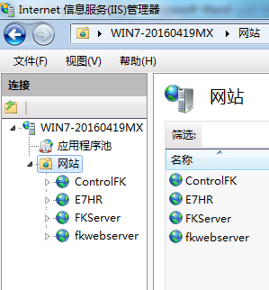

IN IIS Manager, right click “Web Sites” and click New->Web Site…
Description: fkwebserver
Path: the fkwebserver folder path selection
Port: 8041
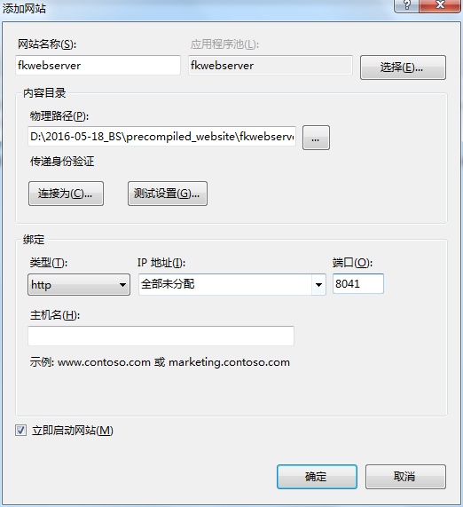
Run scripts(such as ASP) choose and Next
Finish
  - also use the way to add “Web Sites” of ControlFK , but the port is: 8099.
  - SQL Server environment
IN the script file, the sql server DB name: AttDB, uid:sa password:123.
If you want to change , can find the file” web.config” in the “fkwebserver”folder and “ ControlFK” folder. As follow:

<connectionStrings>
<add name="SqlConnFkWeb" connectionString="server=LocalHost\SQLEXPRESS;uid=sa;pwd=123;database=attdb;Min Pool Size=0;Max Pool Size=512;Pooling=true;"/>
</connectionStrings>

- How to create sql server DB.
Intall sql server management, and set UID and password. Create SQL DB named” AttDB”, run the file “CreateDb.sql “ in the “mssql-scripts” folder, as follow:
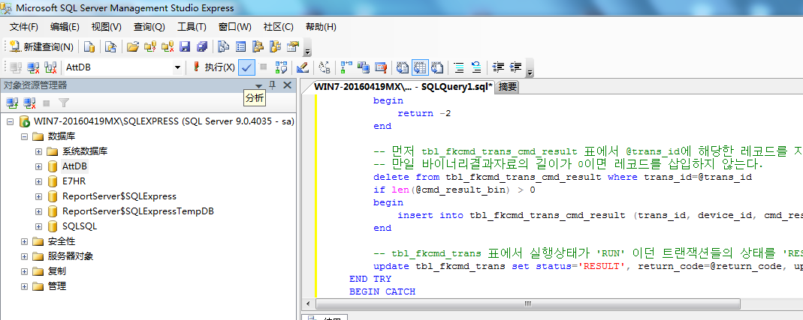
Modify mssql and set the account number and password,creat database name as AttDB ，operation CreateDb.sql file in mssql-scripts folder and combine it in MS SQL.
According to the windows system is 32Bit or 64Bit, the database path is different, modify the path in the CreateDb.sql file, as follow:

IN file “CreateDb.sql”
/****** Object: Database [AttDB] Script Date: 12/21/2013 11:19:05 ******/
CREATE DATABASE [AttDB] ON PRIMARY
( NAME = N'AttDB', FILENAME = N'C:\Program Files\Microsoft SQL Server\MSSQL.1\MSSQL\Data\AttDB.mdf' , SIZE = 3072KB , MAXSIZE = UNLIMITED, FILEGROWTH = 1024KB )
LOG ON
( NAME = N'AttDB_log', FILENAME = N'C:\Program Files\Microsoft SQL Server\MSSQL.1\MSSQL\Data\AttDB_log.ldf' , SIZE = 1024KB , MAXSIZE = 2048GB , FILEGROWTH = 10%)
GO

